Watson and the Shark
By: John Singleton Copley
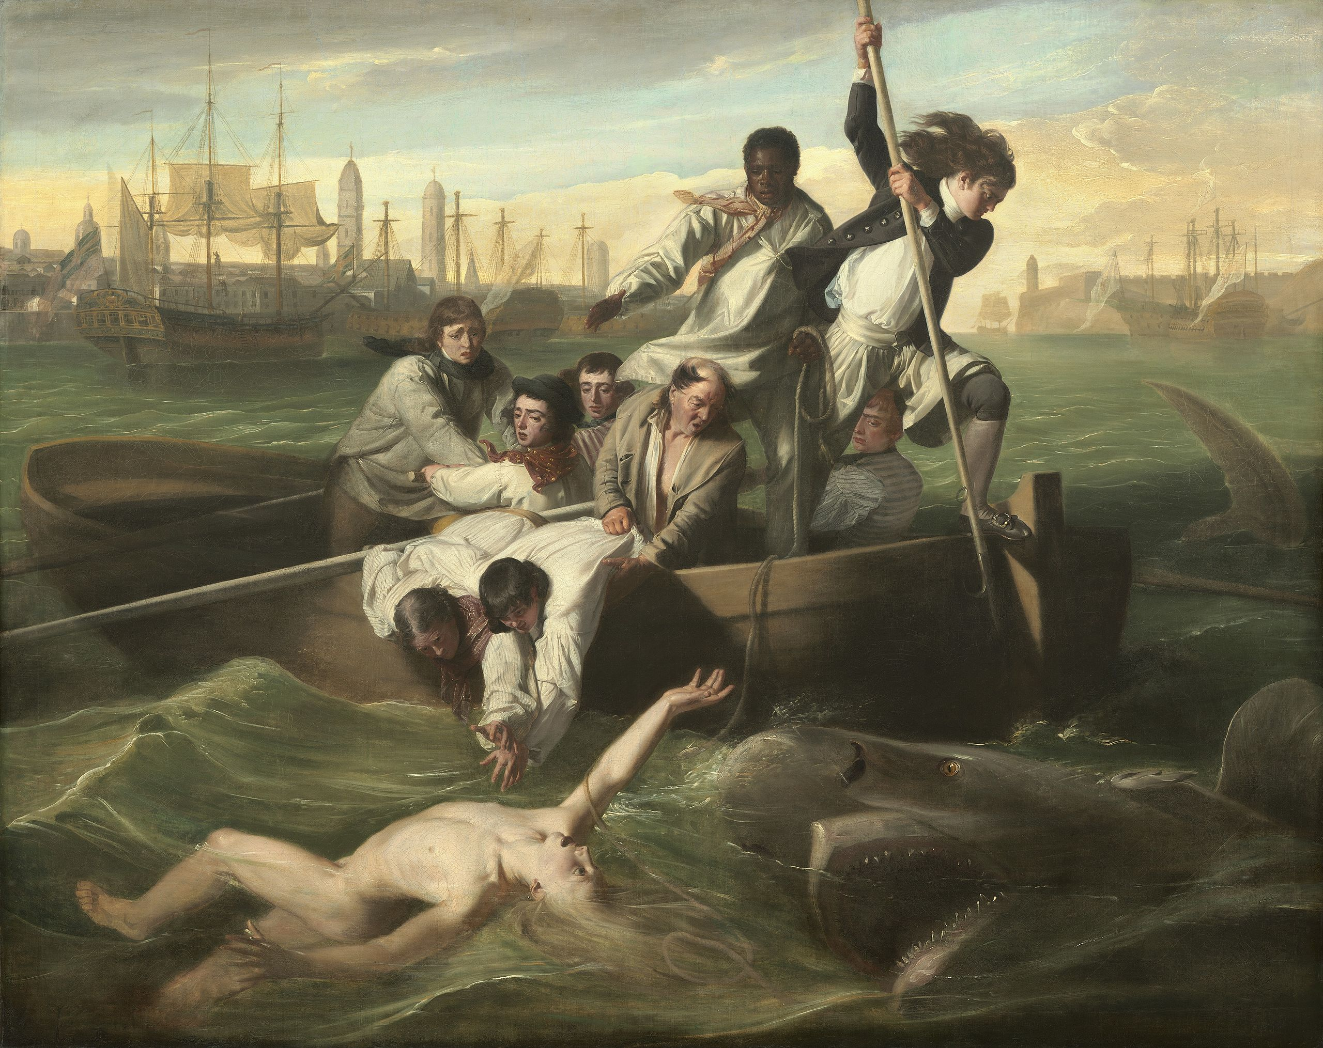
What is going on in this picture?
What makes you say that?
Who might best represent you in this picture? Why?
What else can we see?

