Wheelchair Activity: Best if object is physically with the group.

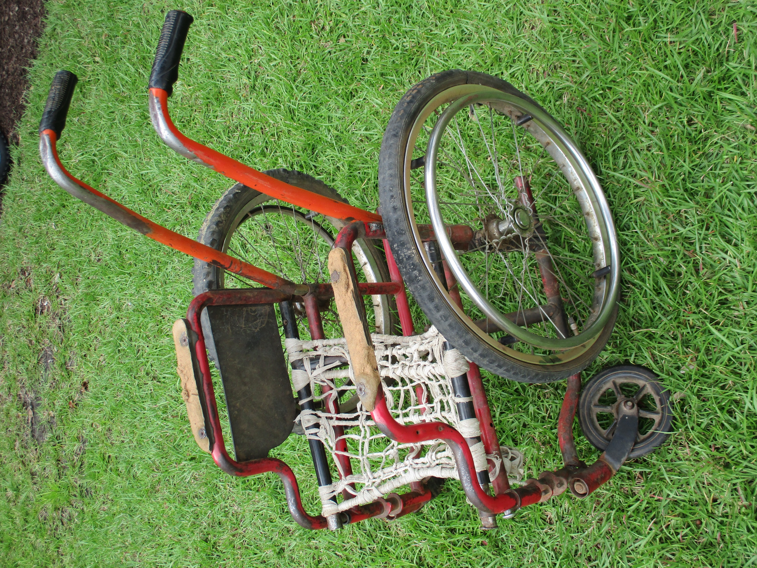

- What do you see?
- What do you think this object could tell us? What is its story?
- What more could it share?

