MOTIONS TEMPLATE
Motion Maker Name: John A. Buford, PT, PhD
Motion Maker Phone: (614) 292-1520 [office] (614) 961-9683 [cell]
Motion Maker E-mail: buford.5@osu.edu

Reference Committee Liaison Name: Lynn Rivers, PT, PhD
Reference Committee Liaison Phone: (716) 829-7708 [office] (716) 698-0991 [cell]
Reference Committee Liaison Email: riversl@dyc.edu

PROPOSED BY: John Buford, PT, PhD

TITLE: A national registry of graduates from accredited physical therapy programs

MOTION:

The ACAPT Board of Directors shall work with CAPTE and the FSBPT to develop a strategic plan, including a timeline, policies, and procedures to determine what would be required to develop and implement a national registry of physical therapists and physical therapist assistants who graduated from an accredited program.

The plan would include but not be limited to:

- Identifying the pros and cons to such a registry process
- The steps needed to ensure that this registry becomes the sole means by which state licensure boards gain verification of the educational completion of an accredited PT or PTA program.
- Any costs to stakeholders

A report of the proposed plan would be provided at the 2019 Annual Meeting with any recommendation for a vote to move forward to next steps for implementation

SUPPORT STATEMENT:

Historically, physical therapy educational programs have had a variety of structures. For the bachelors and certificate degree stages of our profession, completion of the accredited clinical educational program often occurred outside the undergraduate degree. It was common to earn a bachelor’s degree prior to completing the program requirements for licensure. Because of this separation between the degree and program requirements, many university registrars do not maintain records of who has completed the physical therapy program satisfactorily. Whenever a physical therapist moves from one state to another, the state will require certification from the university that the student completed the required program. Because university registrars do not always have all the requisite information, many programs must keep a record of all their graduates since inception. Of course, maintaining a record of graduates may be required for a variety of internal reasons, but there are aspects of this system in relationship to the requirements for verifying completion of the educational program that are slow, duplicative, and risky.

When a physical therapist wishes to gain initial licensure after graduation, or become licensed in a new state later in their career, all states require certification from the program director that the individual graduated and completed the program requirements. Even with the MPT and DPT graduates, who in general would not have received the clinical degree without completion of all parts of the clinical education program, verification from the program is required by the state licensure agencies in addition to the student’s transcripts. Either an official school seal or a notarized signature is required on these forms. There is wide variation in the types of information required with this certification among the states, requiring program directors to maintain extensive files, including restricted data items like social security numbers and dates of birth.

When the graduate moves to a new state, their new employment is contingent upon the program director responding in a timely manner to these requests, which come at all times of year with varying levels of urgency. Despite instructions on websites, etc., many graduates mistakenly contact the registrar or other university officials instead of the program, adding further administrative delay.

Americans are mobile, and physical therapists are no exception. According to the US Census Bureau, between 2% and 4% of all Americans move from one state to another annually. Practical experience as a program director shows this is frequent early in the career, and again late in the career, potentially 30 or more years after graduation. Physical therapy laws and rules should be as nimble as possible to ease the administration burden of regulatory bodies and other stakeholders as Americans move. A national registry of physical therapists and physical therapist assistants may help to ease the administrative burden on the different stakeholders as physical therapy clinicians migrate from one regulatory jurisdiction to another, which would allow clinicians to begin practicing in their new jurisdiction with a faster timeline.

Now that we have a federation of state boards of physical therapy, which has implemented a new system for computerized verification of graduation cohorts, the essential parts of an infrastructure exist to create a modern national registry. The proposal here is that we should study the feasibility of creating one nationally accepted location for states to attain verification of graduation and successful completion of an accredited physical therapy program. In the long run, all state boards would need to agree upon the minimal data set required to satisfy their jurisdictions, so there would be much to do not only in creating a registry, but also in getting state jurisdictions to use it. Hopefully, the minimal dataset could be limited to the truly relevant information, such as the individual’s name, dates of attendance, degree obtained and degree dates, and the date of ultimate program completion. It would be very important to stop requiring programs to maintain data on social security numbers of the graduates. It would be desirable for individual states to agree NOT to require details such as the number of contact hours, the number of weeks of clinical education, etc. The fact that a program was accredited when the student graduated should be all that is needed; the CAPTE minimum standards at the time provide the assurance needed that the program was complete and adequate at the time. CAPTE maintains records of past program accreditations, so the database could be setup only to allow the appropriate schools to enter cohorts for any given year.

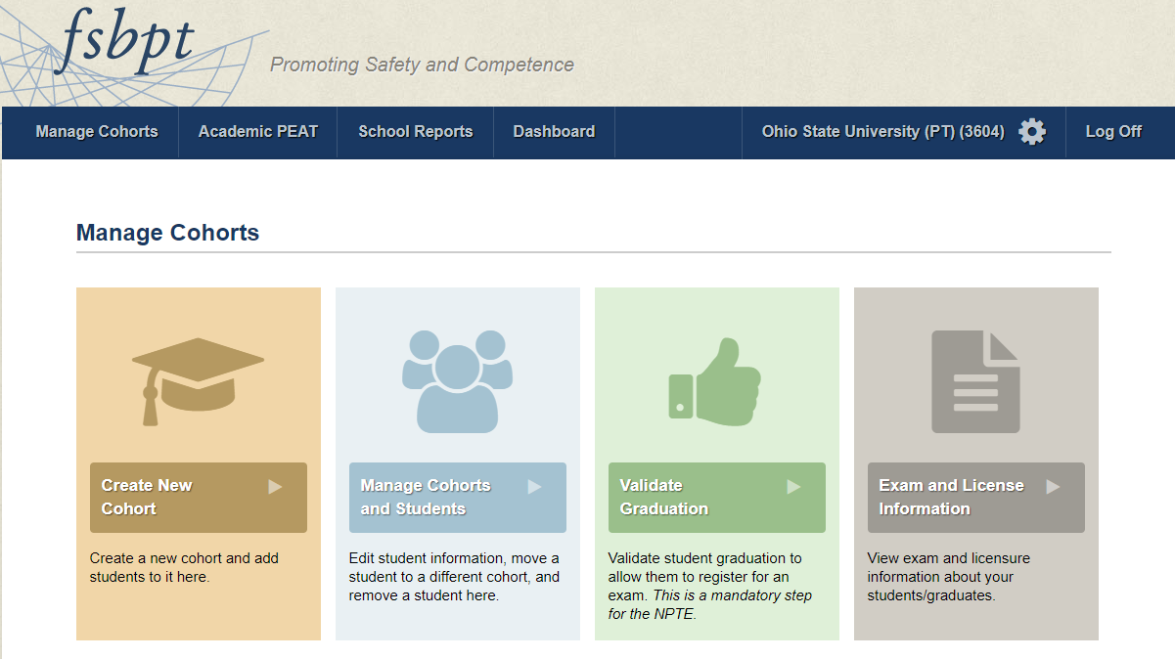

If the FSBPT system could be altered to serve as the home of this registry, we might be very close to having the problem solved. Going forward, programs would certify all new graduates as they go, which has already been done for the 2016 and 2017 years. Presently, we validate graduation, often ahead of time, so that students can sit for the NPTE. If we add a new feature to certify successful completion of the program at the end, then this could satisfy all the information required for states to grant a license. Further, if we added the ability to populate cohorts from the past, we could have one unified system that could be used by all states. The details would be determined later in the process, but one can easily imagine a scenario where programs create a simple spreadsheet with the minimum data (which we all have already in various forms) and send those to the FSBPT for a one time upload. Or, programs could log on and enter the names one at a time. The FSBPT has already built a system to store and secure these data, and many states are beginning to use this system for precertification when testing is allowed early. To cover the costs, a reasonable fee charged to the applicant for providing verification by the FSBPT, in line with what is charged for transcripts by a typical university, would be appropriate.

CURRENT POSITION/STANDARD/GUIDELINE/POLICY/PROCEDURE:

ACAPT does not presently have a position on this issue

RELATED POSITION/STANDARD/GUIDELINE/POLICY/PROCEDURE:

ACAPT in general is supportive of efforts between CAPTE and the FSBPT as fellow stakeholders.

